NEP can act as template for emerging economies to transform human capital
By PTI: November 17, 2023

India's New Education Policy (NEP) can act as a template for emerging economies towards developing strategies and policies for transforming human capital into well-rounded global citizens, Union Education Minister Dharmendra Pradhan said on Friday. Pradhan, who also holds the skill development and entrepreneurship portfolio, made the comments while addressing the second edition of the India-hosted Voice of Global South Summit.
"NEP as a philosophical document can act as a template for emerging economies towards developing comprehensive strategies and agile policies for transforming human capital into well-rounded global citizens with values of compassion and humility," he said. "NEP has catalysed transformation in our education and skill ecosystem and we are eager to share our experience with partner countries," he said.
Pradhan said that no country can solve any problem or achieve goals on its own. "We must act on shared aspirations, devise common strategies, built on the twin pillar of education and skill development. India's experience can serve as an example in this regard. "Built on five foundation pillars of access, affordability, accountability, quality and equity, the NEP aims to create an education system that is rooted in Indian ethos, as well as aligned to the 2030 agenda for sustainable development. It aspires to develop our youth as global citizens with values of humanity and compassion," he said.
The minister said that focusing on seamless integration between schooling and "skilling" is a priority under the NEP to ensure India's youth become a driving force in shaping future. "We have revamped our Study in India portal...We are now welcoming foreign universities to open their campuses in India as well. India will work 'Together for Everyone's Growth, With Everyone's Trust' for global well-being, an equitable world order and for a brighter global future," he said.
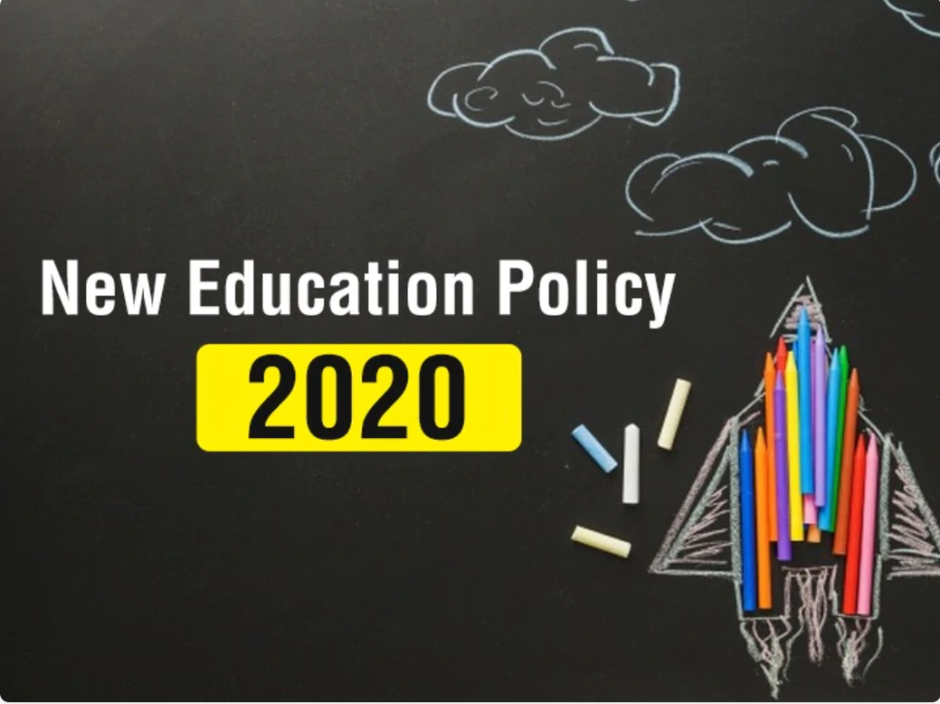
Image: https://www.linkedin.com/pulse/nep-2020-can-india-knowledge-superpower-devi-singh

https://www.hindustantimes.com/education/news/nep-can-act-as-template-for-emerging-economies-to-transform-human-capital-pradhan-101700227571159.html

